CD

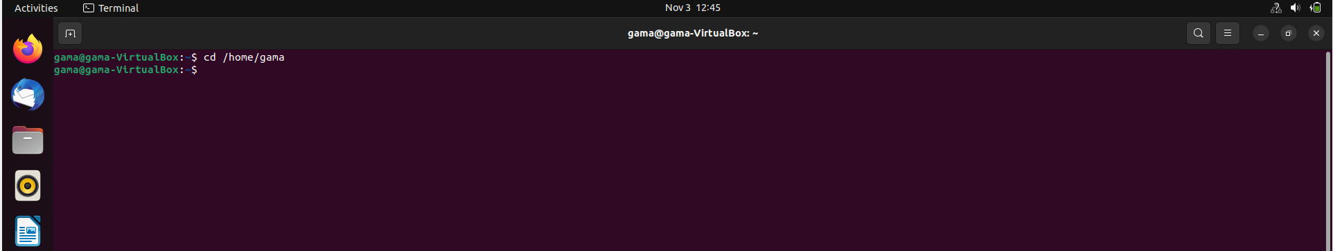

WGET

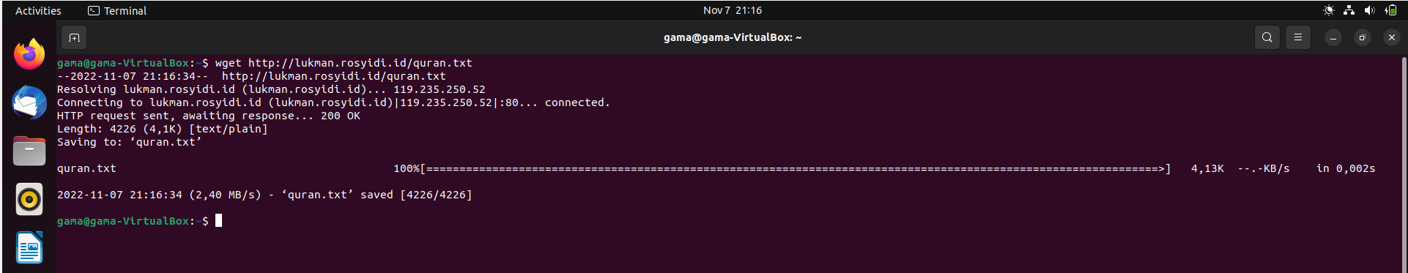

LS -L

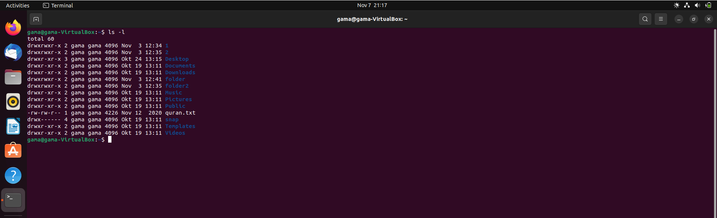

Cat Quran.txt

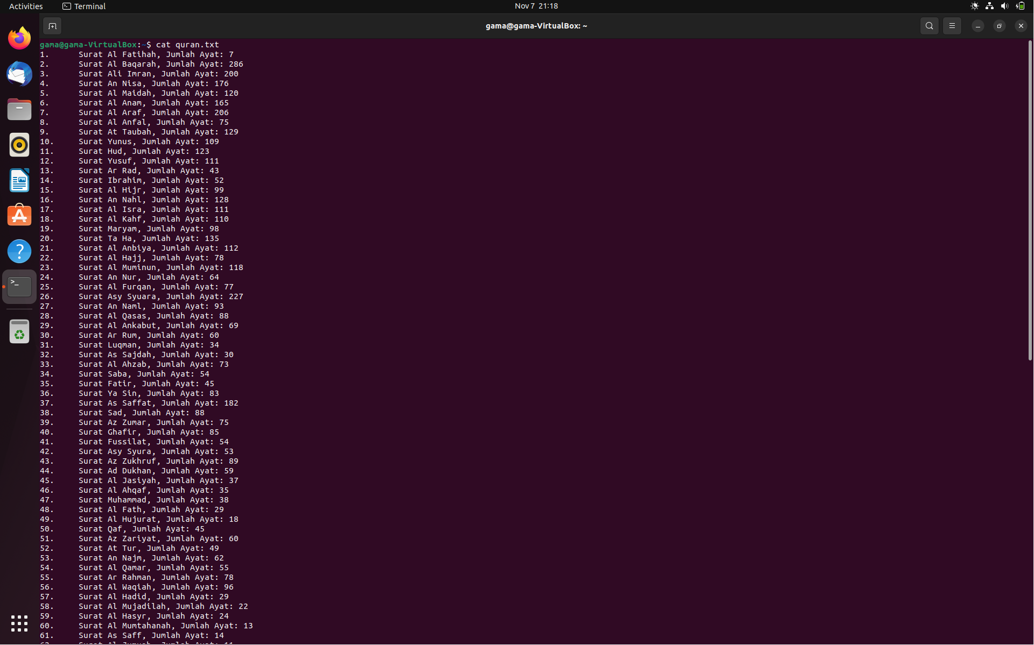

More Quran.txt

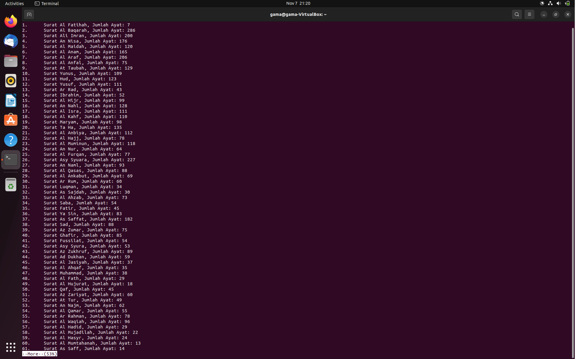

Head -20 quran.txt

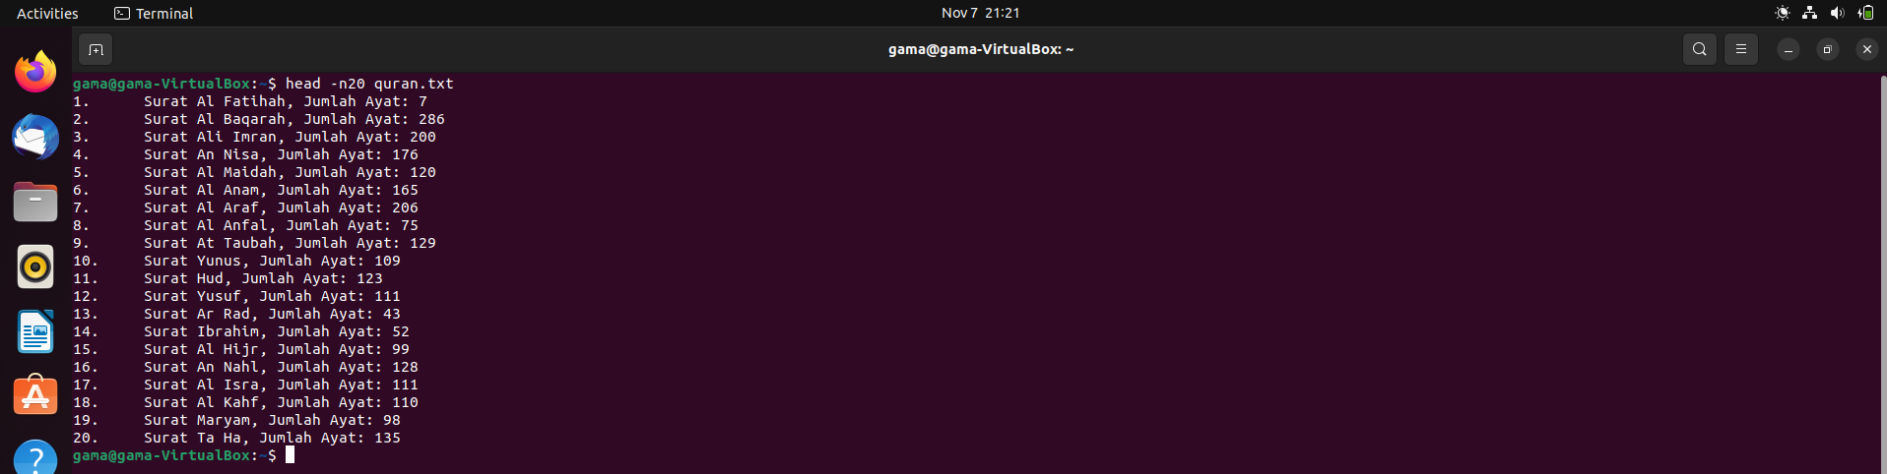

Grep -I luqman quran.txt

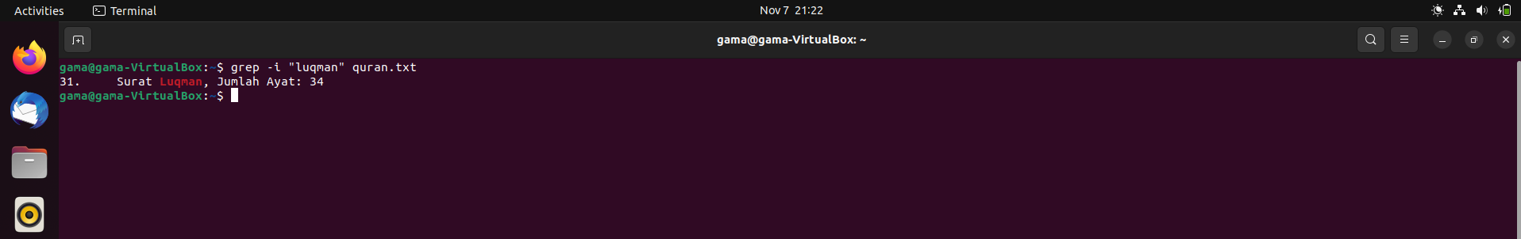

Sed -n 25p

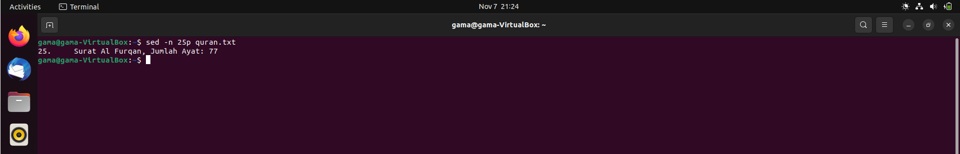

Tai; -37n quran.txt > amma.txt

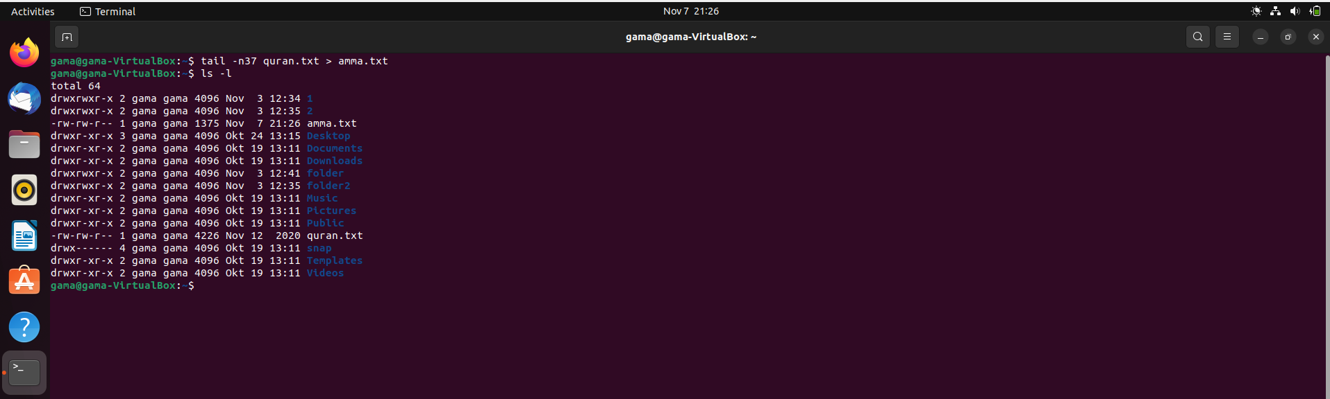

Cat amma.txt

